• Install Power BI Desktop and share the final screenshot of the report view page which appears when power desktop starts.

• Prepare a document and with the following screenshot

There are three views available in Power BI Desktop, which you select on the left side of the canvas. The views, shown in the order they appear, are as follows:

* **Report**: In this view, you create reports and visuals, where most of your creation time is spent.
* **Data**: In this view, you see the tables, measures, and other data used in the data model associated with your report, and transform the data for best use in the report's model.
* **Model**: In this view, you see and manage the relationships among tables in your data model

The following image shows the three views,

**− Report View**

**− Data View**

**− Model View**

**− Power Query Editor**

In Power BI Desktop, you can clean and transform data using the built-in Power Query Editor. With Power Query Editor, you make changes to your data, such as changing a data type, removing columns, or combining data from multiple sources.

**− Advance Editor**

The **Advanced Editor** lets you see the code that Power Query Editor is creating with each step. It also lets you create your own shaping code. To launch the advanced editor, select **View** from the ribbon, then sele

You can directly edit the code in the **Advanced Editor** window. To close the window, select the **Done** or **Cancel** button. ct **Advanced Editor**. A window appears, showing the existing query code.

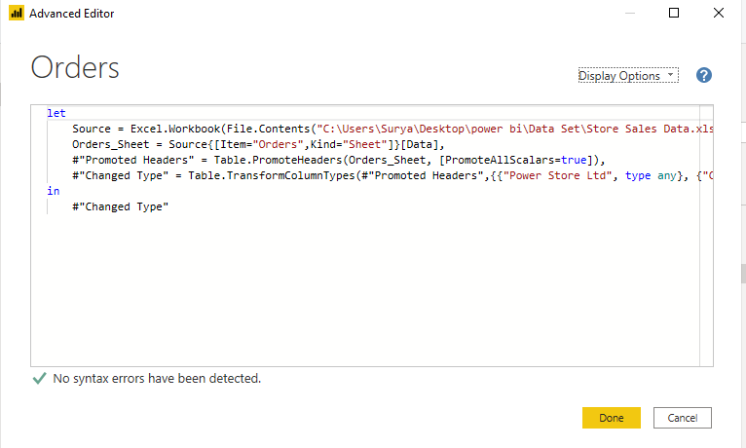

• Prepare a document with details of the following along with their price

**− Power BI Desktop**

Power BI Desktop is a free application you install on your local computer that lets you connect to, transform, and visualize your data. With Power BI Desktop, you can connect to multiple different sources of data, and combine them (often called modeling) into a data model. This data model lets you build visuals, and collections of visuals you can share as reports, with other people inside your organization.

Price: Free

**− Power BI Pro**

**Power BI Pro** is an individual user license that lets users read and interact with reports and dashboards that others have published to the **Power BI** service. Users with this license type can share content and collaborate with other **Power BI Pro** users.

**− Power BI Premium**

With **Premium**, anyone, whether they're inside or outside your organization can view your **Power BI** content including paginated and interactive reports without purchasing individual licenses. **Premium** enables widespread distribution of content by Pro users without requiring Pro licenses for recipients who view the content.

